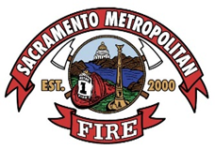
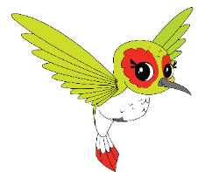
Lesson Plan – MILO & MOXIE
Stay Away from Hot Things
Ages K-2 grade
30 minutes

Teacher Information:
Children younger than six are at the highest risk for burn injuries. Burn injuries in young children occur most frequently from touching a hot object (contact burn) such as a stovetop or an iron. Young children also experience a high number of burns from hot liquids (scalds) such as hot coffee, soup, or tap water.
Young children should be taught the difference between hot and cool, as well as risks of touching hot items. Many things inside and outside the home are hot or could get hot. Things that get hot can cause serious burns. Burn injuries hurt and take a long time to heal. Children need to be able to identify items that are hot and sometimes hot. Children should learn to stay away from anything that can get hot.
Objectives:
- Distinguish between what’s hot and what’s not
- Recognize safe actions around hot and potentially hot items
Materials:
- Milo and Moxie classroom book
- Metro Fire turnout video : https://www.youtube.com/watch?v=uBmrW0lL8tc
Procedure:
- Introduce Milo and Moxie (M&M) and explain that M&M want the kids to be safe in their home.
  - Focus of the lesson is to learn about what’s hot and what’s not and how to be careful around hot things.
- Due to the kids age/attention span we suggest you read parts of book for this lesson. Here are the pages we recommend:
  - Page 1 which begins I’m Milo the dog
  - Page 2 which begins The kitchen is busy
  - Page 3 which begins From handles to pans
  - Page 4 which begins You can’t always see
  - Page 5 which begins Don’t open that pot
  - Skip to Page 9 which begins Smoke detectors sound
  - Skip to Page 13 which begins There’s a lesson
  - Page 14 which begins Fire catches quickly
  - Page 15 which begins So always remember
- After reading the recommended pages, the following concepts should be reinforced:
  - The kids should know the difference between what’s hot and what’s not.
  - Hot things can cause a burn.
  - In the kitchen there are lots of hot things so it’s best to stay out of the kitchen but if you are in the kitchen, you need to stay clear of the stove/oven (3 foot kid-free zone).
  - If they hear the smoke alarm noise, get low and go.
- Introduce the turnout video.
  - A short video of Metro firefighters showing them the clothes firefighters wear into a fire.
- Summarize lesson.

Sacramento Metropolitan Fire District www.metrofire.ca.gov

10545 Armstrong Ave., Suite 200 · Mather, CA 95655 · Phone (916) 859-4300 · Fax (916) 859-3700

